LAB-2

1. Write a C program to simulate SJF scheduling algorithm non preemptive.
Program:
#include<stdio.h>

struct process
{
int pid;
int at;
int bt;
int ct;
int tat;
int wt;
};

void sjf_np(struct process p[], int n){
for(int i=0; i<n; i++){
printf("Enter the process id, arrival time and burst time of process %d: ", i+1);
scanf("%d %d %d",&p[i].pid, &p[i].at, &p[i].bt);
}

int completed = 0, time = 0;
float total_tat = 0, total_wt = 0;
int done[n];
for(int i=0; i<n; i++) done[i] = 0;

while(completed < n) {
int idx = -1, min_bt = 9999;

for(int i=0; i<n; i++) {
if(!done[i] && p[i].at <= time && p[i].bt < min_bt) {
min_bt = p[i].bt;
idx = i;
}
}

if(idx != -1) {
time += p[idx].bt;
p[idx].ct = time;
p[idx].tat = p[idx].ct - p[idx].at;
p[idx].wt = p[idx].tat - p[idx].bt;
total_tat += p[idx].tat;
total_wt += p[idx].wt;
done[idx] = 1;
completed++;
} else {
time++;
}
}
printf("\nPID\tAT\tBT\tCT\tTAT\tWT\n");
for (int i = 0; i < n; i++) {
printf("%d\t%d\t%d\t%d\t%d\t%d\n",
p[i].pid, p[i].at, p[i].bt, p[i].ct, p[i].tat, p[i].wt);
}

printf("\nAverage Turnaround Time: %.2f\n", total_tat/n);
printf("Average Waiting Time: %.2f\n", total_wt/n);

}

int main(){
int n;
printf("Enter number of processes: ");
scanf("%d", &n);
struct process p[n];
sjf_np(p, n);
return 0;
}

Output:
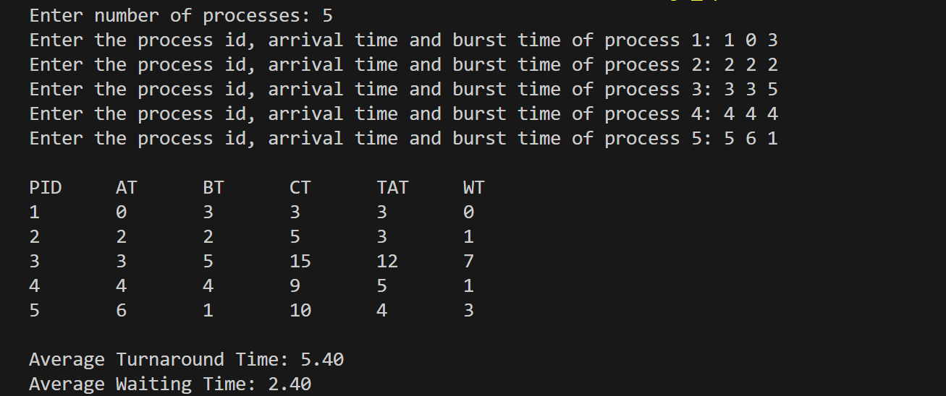

2. Write a C program to simulate SJF scheduling algorithm preemptive.
Program:
#include<stdio.h>

struct process
{
int pid;
int at;
int bt;
int ct;
int tat;
int wt;
int rbt;
};

void sjf_pre(struct process p[], int n){
for(int i=0; i<n; i++){
printf("Enter process id, arrival time and burst time for process %d: ", i+1);
scanf("%d %d %d", &p[i].pid, &p[i].at, &p[i].bt);
p[i].rbt=p[i].bt;
}

int completed = 0, time = 0;
float total_tat = 0, total_wt = 0;

while(completed<n){
int idx=-1, min_rbt=9999;

for(int i=0; i<n; i++){
if(p[i].at<=time && p[i].rbt>0 && p[i].rbt<min_rbt){
min_rbt=p[i].rbt;
idx=i;
}
}
if(idx!=-1){
p[idx].rbt--;
time++;
if (p[idx].rbt == 0) {
p[idx].ct = time;
p[idx].tat = p[idx].ct - p[idx].at;
p[idx].wt = p[idx].tat - p[idx].bt;
total_tat += p[idx].tat;
total_wt += p[idx].wt;
completed++;
}
} else {
time++;
}
}
printf("\nPID\tAT\tBT\tCT\tTAT\tWT\n");
for (int i = 0; i < n; i++) {
printf("%d\t%d\t%d\t%d\t%d\t%d\n",
p[i].pid, p[i].at, p[i].bt, p[i].ct, p[i].tat, p[i].wt);
}

printf("\nAverage Turnaround Time: %.2f\n", total_tat/n);
printf("Average Waiting Time: %.2f\n", total_wt/n);
}

int main(){
int n;
printf("Enter number of processes: ");
scanf("%d", &n);
struct process p[n];
sjf_pre(p, n);
return 0;
}
Output:
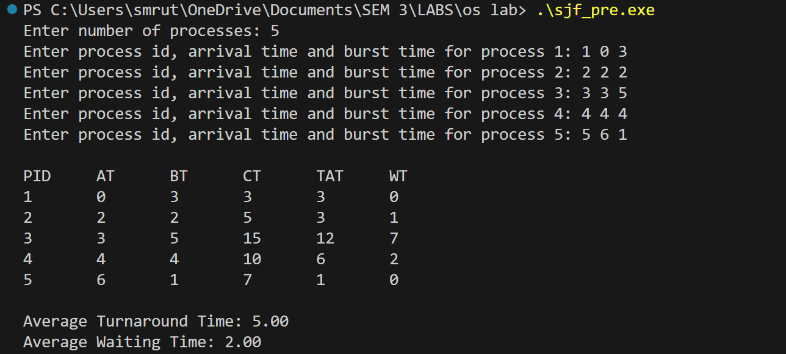

3. Write a C program to simulate priority scheduling algorithm non preemptive.
Program:
#include<stdio.h>

struct process
{
int pid;
int at;
int bt;
int pr;
int ct;
int tat;
int wt;
int completed;
};

void priority_nonpre(struct process p[], int n){

for(int i=0;i<n;i++){
printf("Enter process id, arrival time, burst time and priority for process %d: ",i+1);
scanf("%d %d %d %d",&p[i].pid,&p[i].at,&p[i].bt,&p[i].pr);
p[i].completed = 0;
}

int time = 0, completed = 0;
float total_tat = 0, total_wt = 0;

while(completed < n){

int idx = -1;
int highest_pr = 9999;

for(int i=0;i<n;i++){
if(p[i].at <= time && p[i].completed == 0 && p[i].pr < highest_pr){
highest_pr = p[i].pr;
idx = i;
}
}

if(idx != -1){
time += p[idx].bt;

p[idx].ct = time;
p[idx].tat = p[idx].ct - p[idx].at;
p[idx].wt = p[idx].tat - p[idx].bt;

total_tat += p[idx].tat;
total_wt += p[idx].wt;

p[idx].completed = 1;
completed++;
}
else{
time++;
}
}

printf("\nPID\tAT\tBT\tPR\tCT\tTAT\tWT\n");
for(int i=0;i<n;i++){
printf("%d\t%d\t%d\t%d\t%d\t%d\t%d\n",
p[i].pid,p[i].at,p[i].bt,p[i].pr,p[i].ct,p[i].tat,p[i].wt);
}

printf("\nAverage Turnaround Time: %.2f\n", total_tat/n);
printf("Average Waiting Time: %.2f\n", total_wt/n);
}

int main(){

int n;
printf("Enter number of processes: ");
scanf("%d",&n);

struct process p[n];

priority_nonpre(p,n);

return 0;
}

Output:
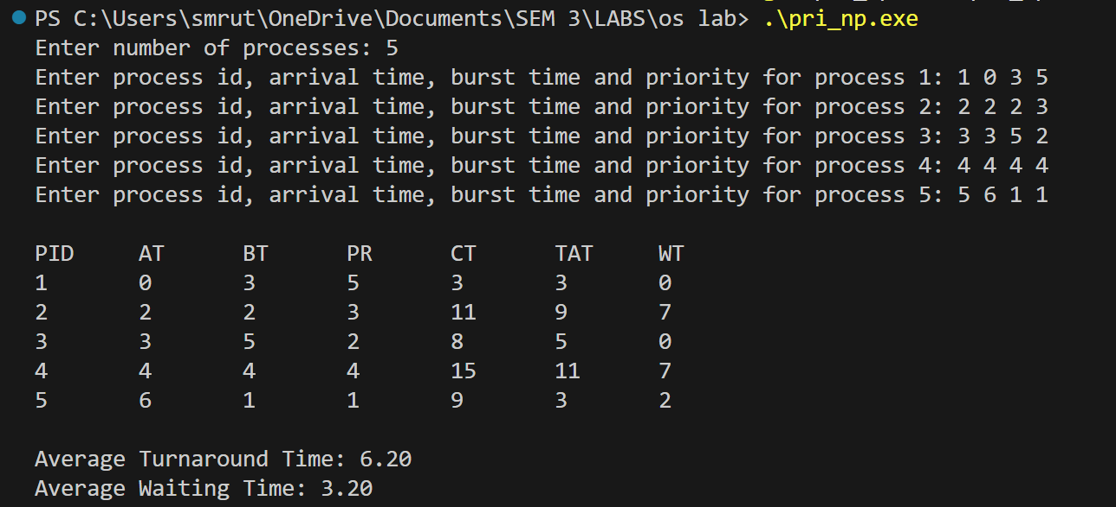

4. Write a C program to simulate priority scheduling algorithm preemptive.
Program:
#include<stdio.h>

struct process
{
int pid;
int at;
int bt;
int pr;
int ct;
int tat;
int wt;
int rbt;
};

void priority_pre(struct process p[], int n){

for(int i=0;i<n;i++){
printf("Enter process id, arrival time, burst time and priority for process %d: ", i+1);
scanf("%d %d %d %d",&p[i].pid,&p[i].at,&p[i].bt,&p[i].pr);
p[i].rbt = p[i].bt;
}

int completed = 0, time = 0;
float total_tat = 0, total_wt = 0;

while(completed < n){
int idx = -1;
int highest_pr = 9999;

for(int i=0;i<n;i++){
if(p[i].at <= time && p[i].rbt > 0 && p[i].pr < highest_pr){
highest_pr = p[i].pr;
idx = i;
}
}

if(idx != -1){
p[idx].rbt--;
time++;

if(p[idx].rbt == 0){
p[idx].ct = time;
p[idx].tat = p[idx].ct - p[idx].at;
p[idx].wt = p[idx].tat - p[idx].bt;

total_tat += p[idx].tat;
total_wt += p[idx].wt;
completed++;
}
}
else{
time++;
}
}

printf("\nPID\tAT\tBT\tPR\tCT\tTAT\tWT\n");
for(int i=0;i<n;i++){
printf("%d\t%d\t%d\t%d\t%d\t%d\t%d\n",
p[i].pid,p[i].at,p[i].bt,p[i].pr,p[i].ct,p[i].tat,p[i].wt);
}

printf("\nAverage Turnaround Time: %.2f\n", total_tat/n);
printf("Average Waiting Time: %.2f\n", total_wt/n);
}

int main(){

int n;
printf("Enter number of processes: ");
scanf("%d",&n);

struct process p[n];

priority_pre(p,n);

return 0;
}
Output:
